EE 603

SPECTRAL ESTIMATION

TAKE HOME EXAM IV

e1124346
Salim SIRTKAYA

14 January 2005
Exercise C6.12: Comparison of Spatial Spectral Estimators

There exists two mutually exclusive uncorrelated complex Gaussian signals with unit power. Their DOAs are Θ₁ =0° and Θ₂ that is varying. The signal correlation matrix is equal to unit matrix. We have an uniform linear array geometry and 10 sensors. We let the seperation betweeen two sensors be λ/2 (for maximum array aperture). The measurements are corrupted by AWG noise with unit power.
N=100 (number of snapshots)
M=10 (number of sensors)
L=2 (number of incoming signals)

Remember that
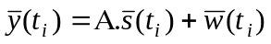, where A is the Vandermonde matrix. This equation represents a single snapshot. We’ll have 100 of them. This will be our data matrix and we’ll estimate the DOAs from this data matrix with Capon, Root MUSIC and ESPRIT methods. The experiments will be repeated 50 times for 50 different realizations.

(a)
Θ₁ =0° and Θ₂ =15°

Figure 1 shows the results of Capon method for 50 realizations. It is observed that the locations of the highest two peaks are the true DOA estimates. In Figure 2, the locations of the DOA estimates are zoomed to establish a more convenient understanding of the method.
It is seen that the two method can estimate the DOAs reliably and the variance is not severe althogh there exist variations in the estimate.
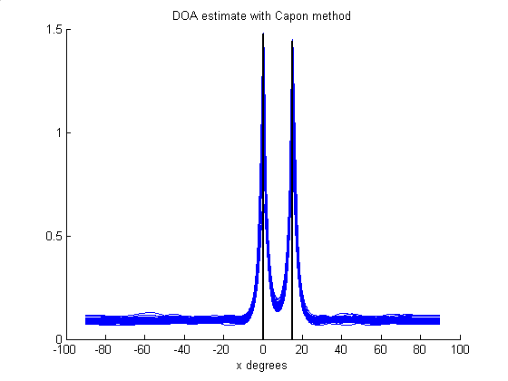
Figure 1 DOA estimates with Capon method for Θ₁ =0° and Θ₂ =15°

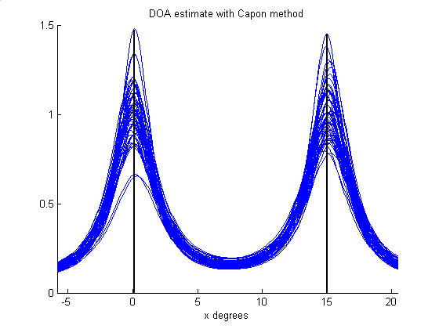
Figure 2 DOA estimates with Capon method (zoomed) for Θ₁ =0° and Θ₂ =15°

Figures 3 and 4 show the DOA estimates with Root MUSIC method. Figure 4 is a zoomed illustration. It is seen that the method is able to estimate the DOAs. And the variance of the estimator good.

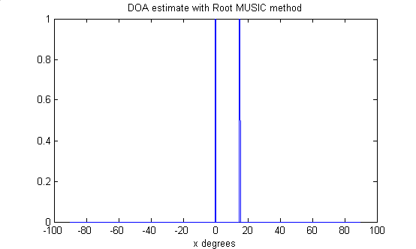
Figure 3 DOA estimates with Root-MUSIC method for Θ₁ =0° and Θ₂ =15°

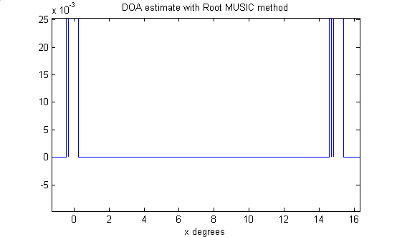
Figure 4 DOA estimates with Root-MUSIC method (zoomed) for Θ₁ =0° and Θ₂ =15°

Figures 5 and 6 show the DOA estimates with ESPRIT method. Figure 6 is a zoomed illustration. It is seen that the method is able to estimate the DOAs. And the variance of the estimator very good.

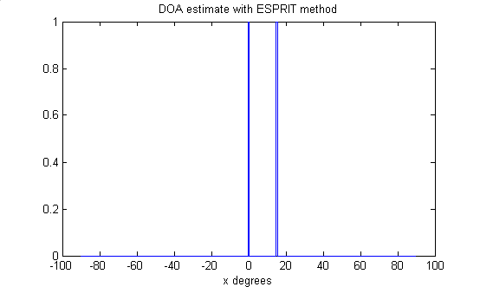
Figure 5 DOA estimates with Esprit method (zoomed) for Θ₁ =0° and Θ₂ =15°

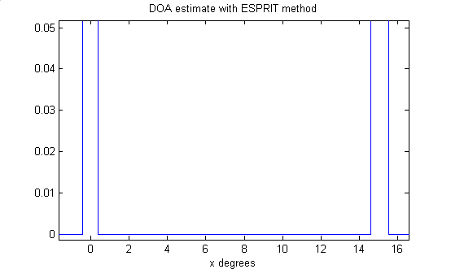
Figure 6 DOA estimates with Esprit method (zoomed) for Θ₁ =0° and Θ₂ =15°

(b)
Θ₁ =0° and Θ₂ =7.5°

Figures 7and 8 show the results of Capon method for 50 realizations. It is seen that (especially from Figure 8), this time the variance and reliability of the estimator is not acceptable

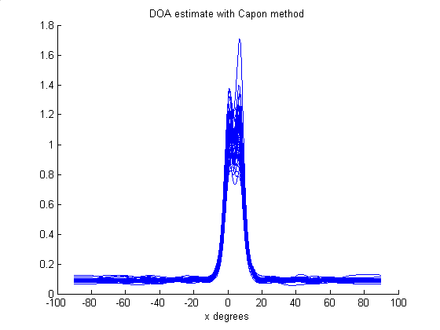
Figure 7 DOA estimates with Capon method for Θ₁ =0° and Θ₂ =7.5°

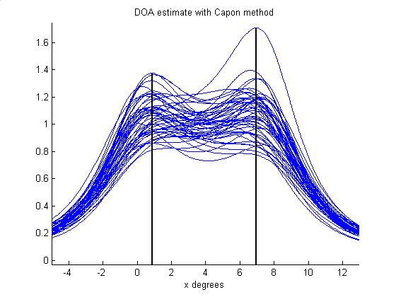
Figure 8 DOA estimates with Capon method (zoomed) for Θ₁ =0° and Θ₂ =7.5°

Figures 9 and 10 show the DOA estimates with Root MUSIC method. Figure 10 is a zoomed illustration. It is seen that the method is able to estimate the DOAs. And the variance of the estimator is still good.

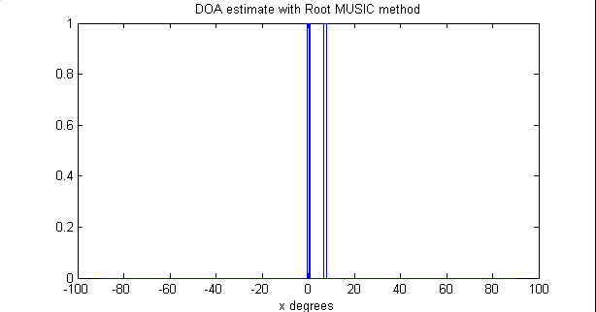
Figure 9 DOA estimates with Root-MUSIC method for Θ₁ =0° and Θ₂ =7.5°

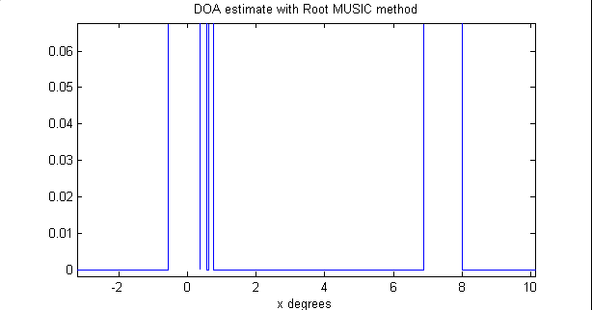
Figure 10 DOA estimates with Root-MUSIC method (zoomed) for Θ₁ =0° and Θ₂ =7.5°

Figures 11 and 12 show the DOA estimates with ESPRIT method. Figure 12 is a zoomed illustration. It is seen that the method is able to estimate the DOAs. And the variance of the estimator still good. It is seen (especially from Figure 12).

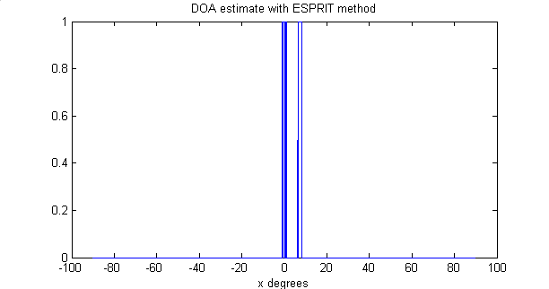
Figure 11 DOA estimates with ESPRIT method for Θ₁ =0° and Θ₂ =7.5°

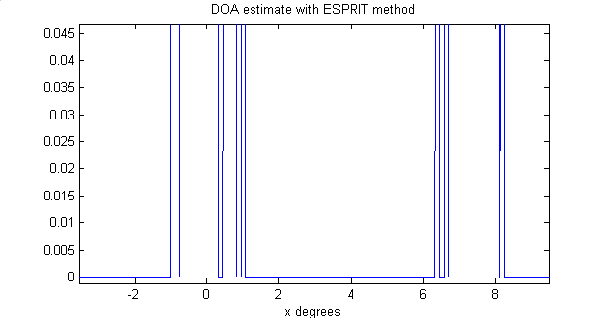
Figure 12 DOA estimates with ESPRIT method (zoomed) for Θ₁ =0° and Θ₂ =7.5°

Comments:
Among the three methods, ESPRIT and Root-MUSIC performed better than Capon method concerning both reliability and variance.
This is an expected result since the Capon method is a non-parametric method and assume anything about the statistical properties of the data. It can be useful when we lack apriori information about data, but if we know something about the data parametric methods will be more useful.

Exercise C6.13: Performance of Spatial Estimators for Coherent Source Signals

This time we have two fully correlated (coherent) signals. Their DOAs are Θ₁ =0° and Θ₂ =15. We have an uniform linear array geometry and 10 sensors. We let the seperation betweeen two sensors be λ/2 (for maximum array aperture). The measurements are corrupted by AWG noise with unit power.

N=100 (number of snapshots)
M=10 (number of sensors)
L=2 (number of incoming signals)

Remember that
, where A is the Vandermonde matrix. This equation represents a single snapshot. We’ll have 100 of them. This will be our data matrix and we’ll estimate the DOAs from this data matrix with Capon, Root MUSIC and ESPRIT methods. The experiments will be repeated 50 times for 50 different realizations.

Figures 13, 14, 15 shows the results of DOA estimation for Capon, Root MUSIC and ESPRIT methods respectively.
It is seen that the performance of the Capon method is decreased but it is the best estimator for coherent signals.
Root-MUSIC is better than ESPRIT but it gives false estimates sometimes

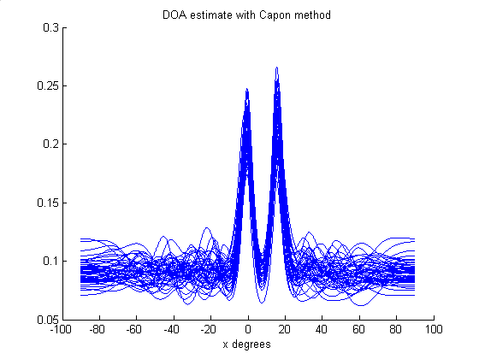
Figure 13 The DOAs with Capon method for coherent signals Θ₁ =0° and Θ₂ =15°

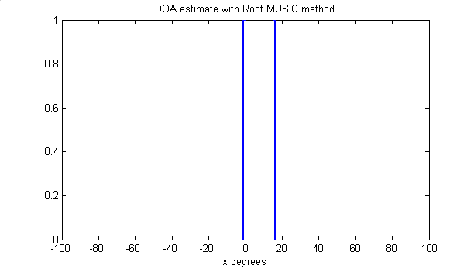
Figure 14 The DOAs with Root-MUSIC method for coherent signals Θ₁ =0° and Θ₂ =15°

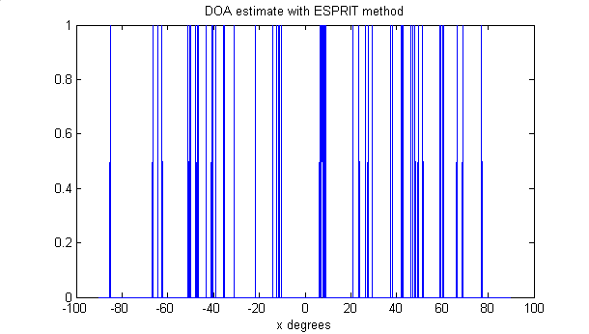
Figure 15 The DOAs with ESPRIT method for coherent signals Θ₁ =0° and Θ₂ =15°

